

Waterford institute of technology

Databases – assignment One

November 22, 2020

Ian Hutchinson (20048122)

HDip iin computer science

2020

Table of Contents

Project Brief 2

Design Document Deliverable 2

Business Description 2

Introduction 2

Benefits 2

Major Business Functions 2

Conceptual Data Model 4

Major Business Entity Types 4

Logical Design 5

Entity Relations 5

Entity Relationships 6

Conclusion 7

# Project Brief

For the design phase, you are to introduce and describe the problem/system/situation that you plan to implement. And construct a Conceptual Data Model (ER diagram) and Logical Data Model (set of relations).

## Design Document Deliverable

This document serves as the design and implementation plan for the database. It is at this stage that the database should be modelled, and associated documentation should be developed.

Link to video description: https://youtu.be/GWhN0XlfV6c

# Business Description

## Introduction

The author is tasked with producing an Entity Relationship (ER) diagram for a metrology lab located in Waterford City. A company MetCal wishes to create a database to track and maintain data about the instruments and equipment for its clients. MetCal offer calibration and repair services for the following areas: Electrical Calibration, Temperature-Humidity Calibration, Mass Calibration, Pressure Calibration and Time and Frequency. MetCal maintains instruments for several clients across a range of industries based in the south and south east of Ireland. MetCal wants to record information about the equipment history that can be accessed later. When referring to instrument, equipment or a unit, they are essentially used in describing the same thing.

## Benefits

The benefit of creating a centralised database is to provide an efficient platform to track MetCals staff members, suppliers, customers and equipment. A database that complies with the requirements set out in 21 CFR Part 11 and ISO 9001:2015 will give current and prospective clients confidence in the management and storage of their confidential information. With access to a complete history of each piece of equipment a secondary advantage is the ability to track drift or other issues before they cause a deviation. MetCal can assist clients in trouble shooting problems related to processes that may arise due to issues related to their equipment.

## Major Business Functions

* Each staff member may handle enquires by zero or many customers with customers possibly (or possibly not) making an enquiry of about MetCals range of services. Details of customer queries are recorded (date of enquiry and enquiry type).
* A maximum of five calibration technicians can work in the lab at any one time to enable safe social distancing due to covid-19. A Supervisor is responsible for managing operation of the lab. Details to be recorded include: staffId (unique), staff name (fName, lName), date of birth, position and salary.
* An individual staff member may (or may not) create several take several bookings with an individual booking being created by one and only one staff member. Each customer will make zero or many bookings, with each booking being made by on and only one customer. The booking is associated with one and only one calibration/ repair job. With each calibration/Repair Job associated with one and only one booking.
* For each job, the instrument description is recorded and saved against the owner/ customer. Details: serialNumber, modelType, manufacturer, description (serialNo, modelType, manufacturer), dateIn, dateOut, calDueDate and customerId.
* A repair job may use zero or many parts and a part can be used in zero or more repair jobs. For each part we record a part number, description, quantity in stock and the cost of the part.
* MetCal tracks a list of customers who book in calibration and repairs jobs. Each customer may operate across one or more sites. Their customerId, companyName, pointOfContact(fName, lName), address(street, town and county) and telephone number are recorded.
* MetCal record the supplier details for the supplier who supplies each part. These details include: supplierId, supplierName, address (street, town, province and country), telNo and emailAddress.
* A standard calibration involves as-found verification data only and adjustments are only made in the event of drift or out of tolerances. In the case where spare parts are required, only one staff member will work on one or more repairs for each piece of equipment.
* For billing purposes, before equipment and paperwork is returned to the customer, a purchase order (P.O.) number must be present before returning the equipment to the customer.

# Conceptual Data Model

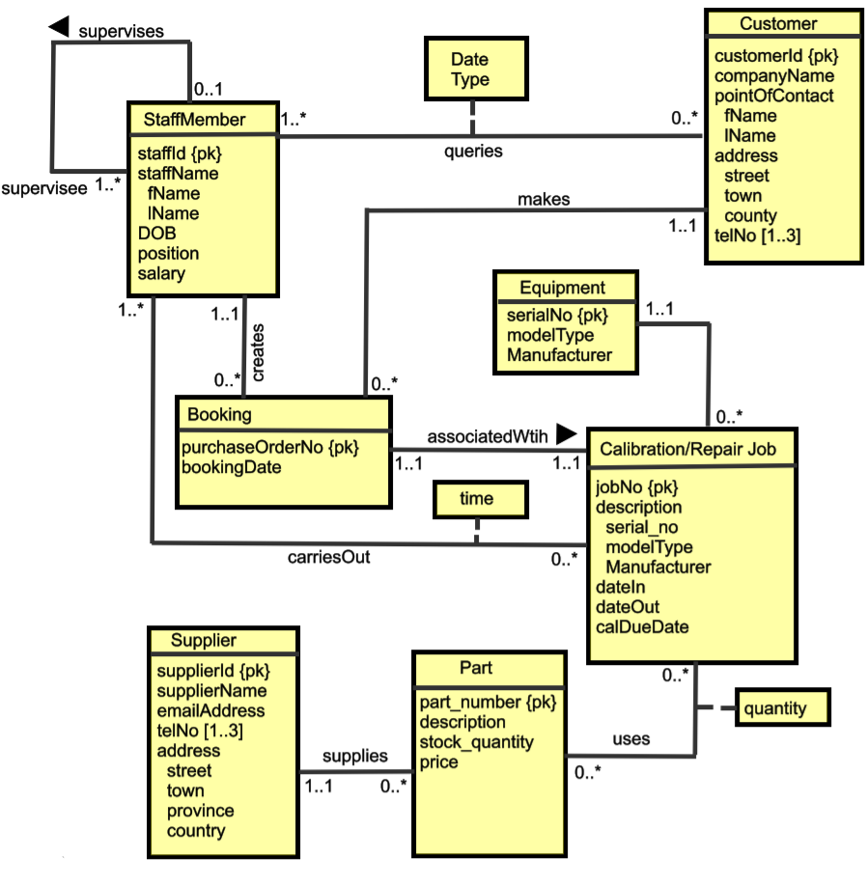

## Major Business Entity Types

* Customer
* Booking
* Staff Member
* Calibration/Repair Job
* Part
* Supplier

# Logical Design

This section maps the ER diagram for METCal’s proposed database into a set of relations and relationships.

Entity Relations

**Customer** (customerId, companyName, fname, lname)   
Primary key customerId

Since the customer sites attribute is multivalued, it is moved to a new relation and includes a copy of the primary key **(**cusotmerId).

**customerSites** (street, town, county, telNo, customerId)

Primary Key telNo

Foreign Key customerId references **Customer** (cusotmerId)

**Booking** (purchaseOrderNo, bookingDate, customerId, staffId)

Primary Key purchaseOrderNo

Foreign Key customerId references **Customer** (cusotmerId)

Foreign Key staffId references **staffMemeber** (staffId)

**staffMember** (staffId, fName, lName, DOB, role, salary, supervisor)

Primary Key staffId  
Foreign Key supervisor references **staffMember** (staffId)

**Calibration/RepairJob** (jobNo, serialNo, modelType, manufacturer, dateIn, dateOut, caDueDate, cusotmerId, purchaseOrderNo)   
Primary key jobNo

Foreign Key customerId references **Customer**(cusotmerId)

Foreign Key purchaseOrderNo references **Booking** (purchaseOrderNo)

**Part** (partNumber, description, stockQuantity, partPrice, supplierId)   
Primary key partNumber

Foreign Key supplierId references **Supplier**(supplierId)

**Supplier**(supplierId, SupplierName, emailAddress, address, street, town, province, country)   
Primary key supplierNumber

**supplierPhones**(telNo, supplierId)

Primary Key telNo

Foreign Key supplierId references **Supplier**(supplierId)

Entity Relationships  
The ‘queries’ relationship between Customer and Staff is *:* and optional on the staff member side. The relationship attribute ‘date and type’ is also placed in this table.

**queries** (customerId, staffId, date, type)

Primary Key customerId, staffId

Foreign Key customerId references **Customer**(customerId)

Foreign Key staffId references **staffMember**(staffId)

The ‘carriesOut’ relationship between staff member and calibration/Repair Job is *:* and optional on the staff members side. Primary keys from both tables in the relationship are posted as foreign key values. The relationship attribute ‘time’ is also placed in this table.

**carriesOut**(staffId, JobNo, time)

Primary Key staffId, JobNo

Foreign Key staffId references **StaffMember**(customerId)

Foreign Key jobNo references **Calibration/Repair Job**(jobNo)

The ‘uses’ relationship between Calibration/Repair Job and Part is 1:* and optional on Calibration/Repair Job side. The relationship attribute is also placed in this new table.

**uses** (JobNo, partNumber, quantity)

Primary Key JobNo, partNumber

Foreign Key jobNo references **Calibration/Repair Job**(jobNo)

Foreign Key partNumber references **Part**(partNumber)

# Conclusion

Working with MetCal, it was possible to design a database to meet its current and future requirements. It will provide MetCal with many benefits that improve data integrity and ability to manage business processes efficiently. MetCals requirements were taken on board and translated from a conceptual design to a logical physical design. The logical design focused on producing the most effective way of storing data and map the logical relations and relationships between entities. A visual and written representation of these business entities was used as a tool to successfully communicate the design to MetCal.

The implementation of the physical database was created using MySQL workbench. The design had been adjusted slightly from the first submission. Initially the telephone number in customer table was assigned to multi-valued attribute. Later it was decided it was better suited to replace it instead with customer site table as each site only has one phone number. A separate customer site table will contain the customer location in addition and telephone details rather than against each customer for that site. The customer table is altered from first submission to accommodate these changes.

Overall, the implementation of the database set out in the design phase has been largely successful. The one aspect that has fallen short is the check on new customers being added to the database. A limit of 3 is set out in the design doc which was difficult to implement. There are triggers and procedures created to capture before insert but not working as they should be. All other tables, scripts etc. are executing without issue.